**Operating Systems - Lab 08 Tasks**

Ibrahim Johar Farooqi

23K-0074

BAI-4A

26 March 2025

**Lab Questions:**

**Task 1 - a:**

**Declare three float arrays A, B and C each of size 1e7 (10000000) and perform the operation C = A + B for each element of A, B and C.**

**a) Write, compile, and run serial code.**

#include <stdio.h>

#include <stdlib.h>

#include <time.h>

#define N 10000000 //10 million

float A[N], B[N], C[N];

void initalise()

{

for(int i = 0; i < N; i++)

{

//random values btw 0 to 100

A[i] = (float)(rand() % 100);

B[i] = (float)(rand() % 100);

}

}

void serial_addition()

{

for (int i = 0; i < N; i++)

{

C[i] = A[i] + B[i];

}

}

int main()

{

clock_t start, end;

double time_taken;

initalise(); //A & B initialised

start = clock(); //start time

serial_addition(); //computation performed here

end = clock(); //end time

time_taken = ((double)(end-start)) / CLOCKS_PER_SEC;

printf("time taken (serial): %.6f secs\n", time_taken);

return 0;

}

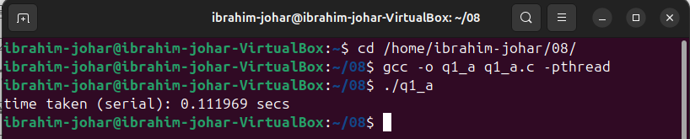

**Task 1 - b:**

**b) Write concurrent code where 10 worker threads will equally divide the computational workload.**

#include <stdio.h>

#include <stdlib.h>

#include <pthread.h>

#include <time.h>

#define N 10000000 //10 million

#define NUM_THREADS 10 //num of worker threads

float A[N], B[N], C[N];

typedef struct {

int start;

int end;

} thread_data;

void initalise()

{

for(int i = 0; i < N; i++)

{

//random values btw 0 to 100

A[i] = (float)(rand() % 100);

B[i] = (float)(rand() % 100);

}

}

void parallel_addition(void* arg)

{

thread_data* data = (thread_data*)arg;

for(int i = data->start; i < data->end; i++)

{

C[i] = A[i] + B[i];

}

pthread_exit(NULL);

}

int main()

{

pthread_t threads[NUM_THREADS];

thread_data th_data[NUM_THREADS];

clock_t start, end;

double time_taken;

initalise();

start = clock();

//creating threads

int chunk_size = N / NUM_THREADS;

for (int i = 0; i < NUM_THREADS; i++)

{

th_data[i].start = i * chunk_size;

th_data[i].end = (i+1) * chunk_size;

pthread_create(&threads[i], NULL, parallel_addition, &th_data[i]);

}

//joining threads

for (int i = 0; i < NUM_THREADS; i++)

{

pthread_join(threads[i], NULL);

}

end = clock();

time_taken = ((double)(end - start)) / CLOCKS_PER_SEC;

printf("time taken (parallel w/ %d threads): %.5f seconds\n", NUM_THREADS, time_taken);

return 0;

}

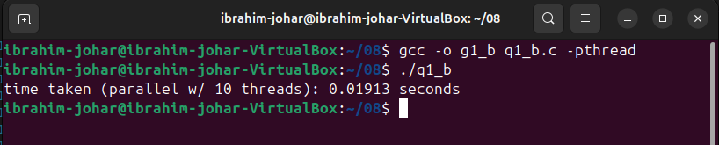

**Task 2:**

**Write a multithreaded program that calculates various statistical values for a list of numbers.This program**

**will pass a series of numbers on the command line and will then create three separate worker threads. One**

**thread will determine the average of the numbers, the second will determine the maximum value, and the**

**third will determine the minimum value. For example, suppose your program is passed the integers. (The array of numbers must be passed as parameter to threads, and the thread must return the calculated value to main thread).**

**90 81 78 95 79 72 85**

**The main thread will print:**

**The average value is 82.**

**The minimum value is 72.**

**The maximum value is 95.**

#include <stdio.h>

#include <stdlib.h>

#include <pthread.h>

#include <limits.h>

typedef struct {

int *numbers;

int count;

} thread_data;

void* calc_avg(void* arg) //thread func -> average

{

thread_data* data = (thread_data*)arg;

int sum = 0;

for (int i = 0; i < data->count; i++)

{

sum += data->numbers[i];

}

double* avg = malloc(sizeof(double));

*avg = (double)sum / data->count;

return avg;

}

void* calc_min(void* arg) //thread func -> minimum

{

thread_data* data = (thread_data*)arg;

int* min = malloc(sizeof(int));

*min = INT_MAX; //initial large val

for (int i = 0; i < data->count; i++)

{

if (data->numbers[i] < *min)

{

*min = data->numbers[i];

}

}

return min;

}

void* calc_max(void* arg) //thread func -> maximum

{

thread_data* data = (thread_data*)arg;

int* max = malloc(sizeof(int));

*max = INT_MIN; //initial small val

for (int i = 0; i < data->count; i++)

{

if (data->numbers[i] > *max)

{

*max = data->numbers[i];

}

}

return max;

}

int main(int argc, char* argv[])

{

if (argc < 2)

{

printf("Usage: %s <list of numbers>\n", argv[0]);

return 1;

}

//converting cmd-line args to an int array

int count = argc - 1;

int nums[count];

for (int i = 0; i < count; i++)

{

nums[i] = atoi(argv[i+1]);

}

//data for threading

thread_data data;

data.numbers = nums;

data.count = count;

pthread_t threads[3];

//3 worker threads

pthread_create(&threads[0], NULL, calc_avg, &data);

pthread_create(&threads[1], NULL, calc_min, &data);

pthread_create(&threads[2], NULL, calc_max, &data);

//collect results

double* avg;

int* min;

int* max;

pthread_join(threads[0], (void**)&avg);

pthread_join(threads[1], (void**)&min);

pthread_join(threads[2], (void**)&max);

printf("The average value is %.2f\n", *avg);

printf("The minimum value is %d\n", *min);

printf("The maximum value is %d\n", *max);

//free allocated memory

free(avg);

free(min);

free(max);

return 0;

}

